**LINUX ASSIGNMENT (REMAINING QUESTIONS)**

Q. 1. When we create a user, some hidden files are generated in the directory of the

same user at that time. How is it done?

Ans. Hidden files and directories in the home directory contain settings or data that’s accessed by that user’s programs. They’re not intended to be edited by the user, only the application. That’s why they’re hidden from the user’s normal view. In general files from your own home directory can be removed and changed without damaging the operating system. When you remove a hidden file from the home directory, you’ll typically lose the settings for the application associated with it. Some of these files are configuration files (like .bashrc  .vimrc and .zshrc), user profiles (like .profile or .bash_profile) and some application configuration files for specific applications.

In most cases the hidden files in your Linux home directory as used to store user settings. This includes settings for command-line utilities as well as GUI-based applications. Removing them will remove user settings. Typically, it won’t cause a program to break.

Q. 2. tac command vs cat command

Ans. Both cat and tac commands are used to concatenate two or more files. They also display the contents of the files on the terminal as output. The basic difference is that tac command works like the reverse of cat command, tac command prints the contents of the file in reverse order.

**For e.g. there are two files FirstFile.txt and SecondFile.txt. Their contents are –**

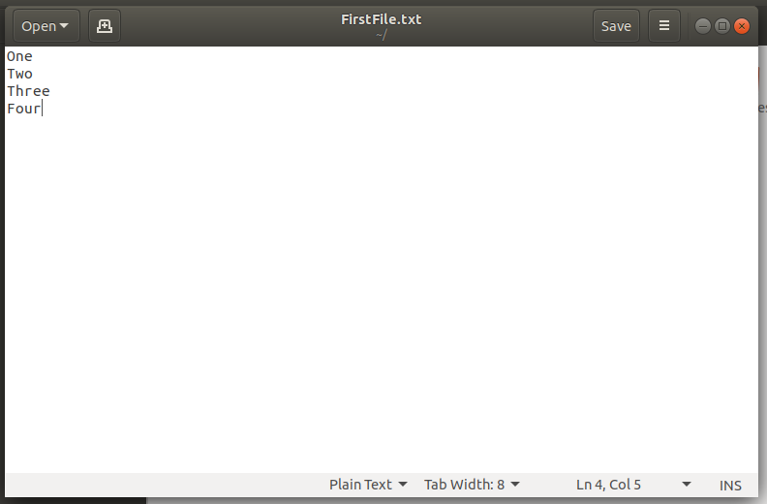

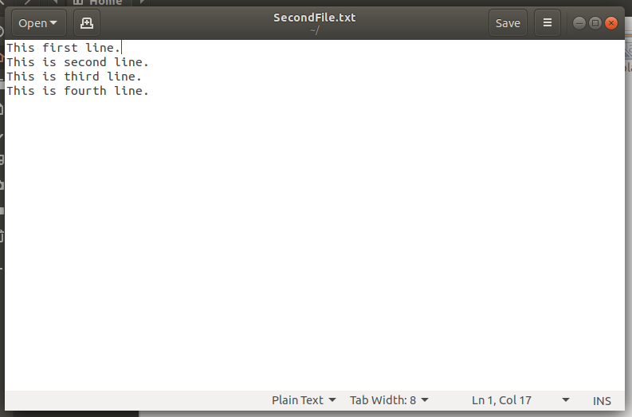

**The output of both the commands on these text files will be –**

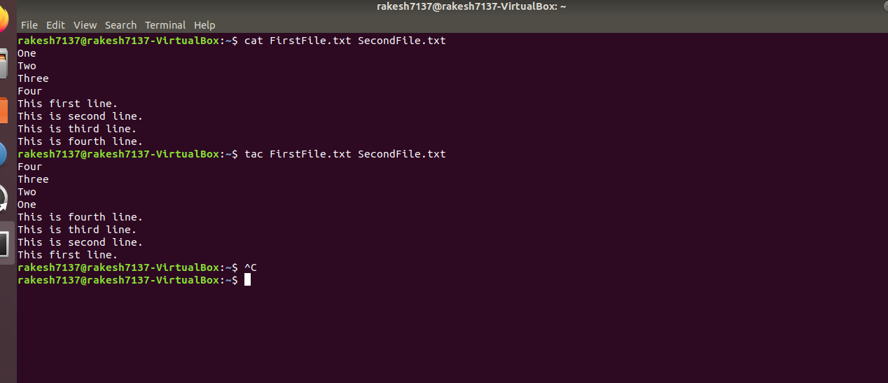

Q. 3. Read a file and show the data on terminal using file input & output redirection.

Ans.

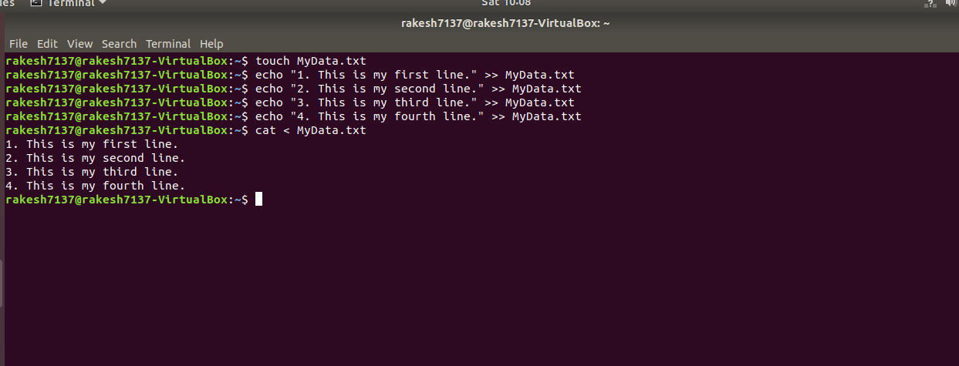

🡪 Change the Umask value for any user permanently.

For this I changed the Umask value in the /etc/login.defs file, but it didn’t show any effect when I checked the umask value on terminal.

🡪 Add a new user without using adduser & useradd command

For this I created entries for the new user in /etc/passwd and /etc/group files. But it showed errors.

Sir if you may kindly give me a step by step procedure to do these tasks after assessing my assignments that would be a great help.